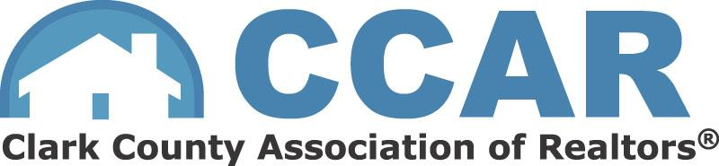

Clark County Sheriff Questionnaire

- As sheriff how would you procure additional financial resources for officer staffing, compensation, training, equipment, and infrastructure like jails?

- What is the current state of public safety in Clark County and what is your plan to improve it?

- How has recent legislation from the state impacted law enforcement, and in your opinion, what is criminal justice reform?

- What is your plan to improve community relations with the sheriff’s office?

- How would you handle and address non-violent crimes like property crimes, catalytic converter theft, vehicle burglary, etc.

- Given mental illness can play a role in law enforcement interactions, how would you handle and address mental illness as sheriff?

- What is your plan to increase and maintain staffing at the Sheriff’s Office?

- How has policing evolved and where do you believe it is heading?

- How would you approach the issue of homelessness in our community, what are some potential solutions?

- How will you partner with other police chiefs and organizations to make Clark County a safer place?

